**Practical 1**

LINUX

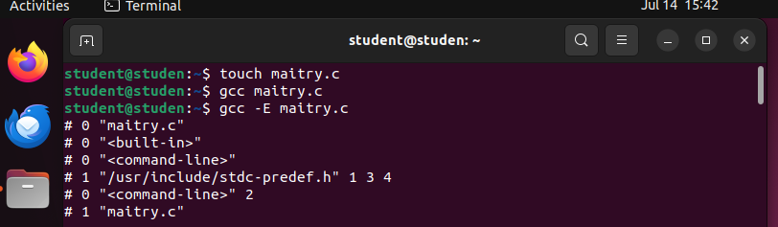

* the first file is formed by the touch tool
* It is named in format Here of “ name.c”

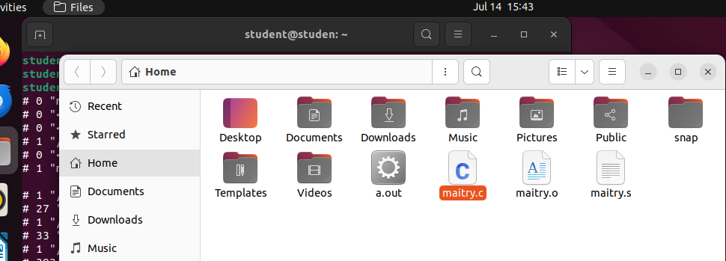

* The other folder is maitry.s
* And the third folder is maitry.o
* This maitry.o will not open. As it has codes which not shown as someone would might copy it.

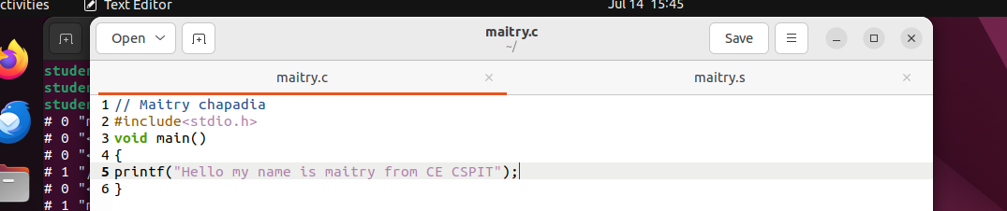

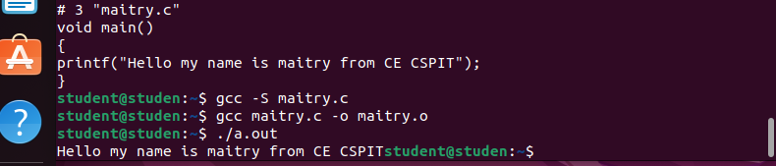

* We got the output by “./a.out” which creates a folder of it.

CODEBLOCK

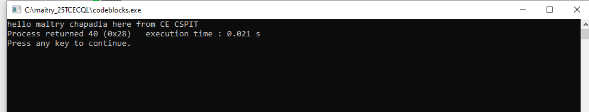

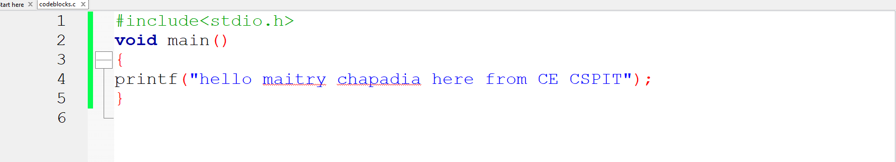

Integer

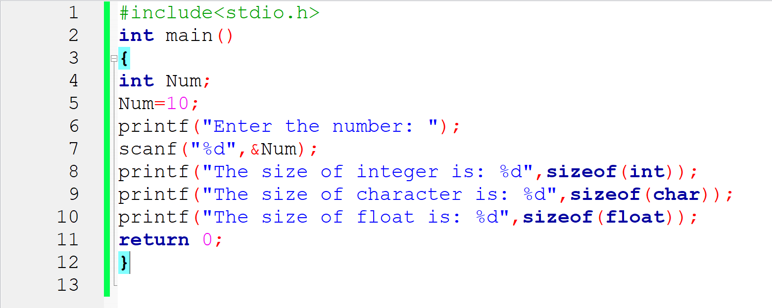

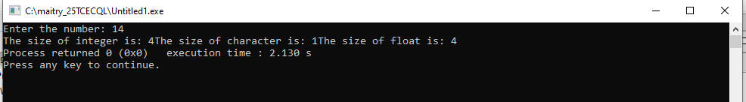

**Practical 2**

Integer Que

To find the area and the perimeter of the park whose length is 70 and breadth is 90 in the codeblock

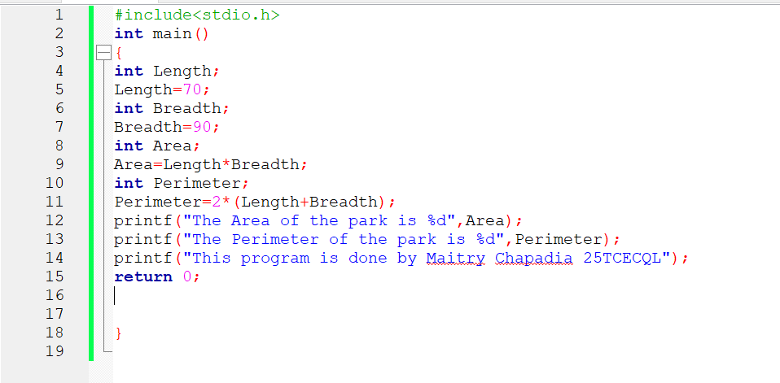

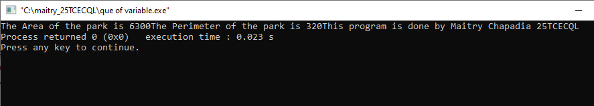

**Practical 3**

Measurements

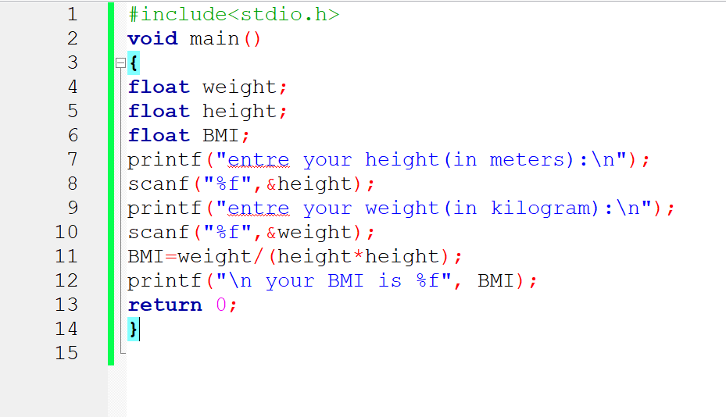

* here the float express the variables.
* Scanf is used for the next line .
* For scanf we use “%f”.
* BMI=weight devided by the square of height.

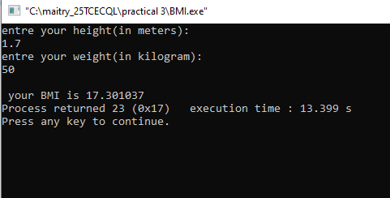

**Practical 5**

Population

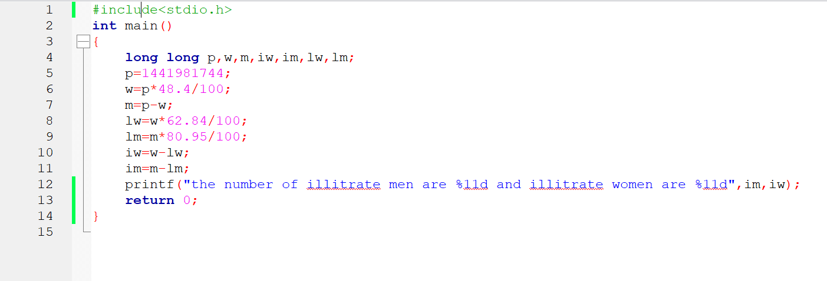

* Here there is the calculation of illiterate men and women from total population of 1,44,19,81,744 people
* Here we have given the percentage of literate men and literate women

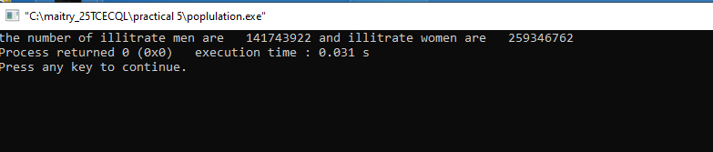

* So we get illiterate men 141743922 and illiterate women 259346762

**Practical 4**

Size and Ranges

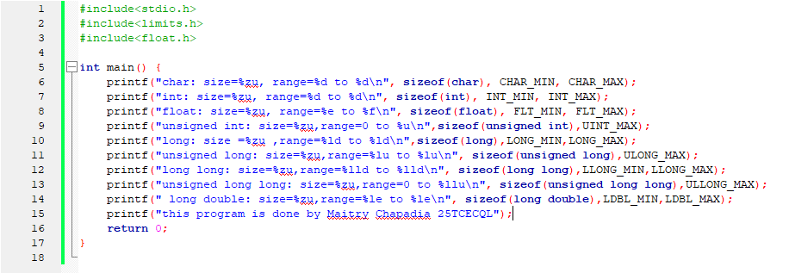

* Here very data type has it’s own size and ranges.

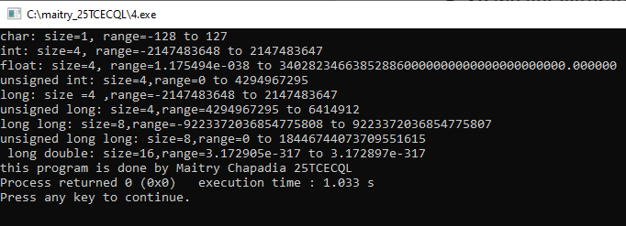

**Practical 6**

Temperature conversation

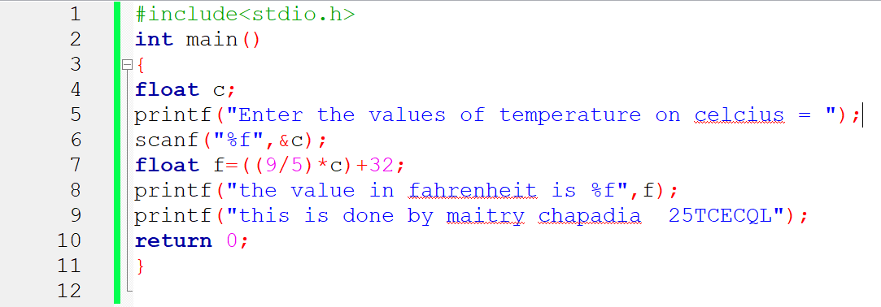

* Here we are doing the conversion of temperature from Celsius to fahrenheit
* With formula ((9/5)*C)+32

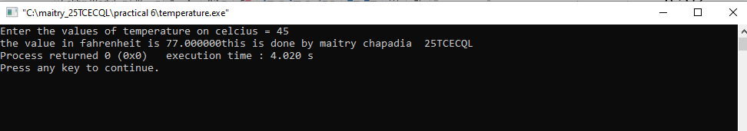

* Here we entre the values of temperature in Celsius and get the answer in Fahrenheit.